Topics: Descriptive Statistics and Probability

1. Look at the data given below. Plot the data, find the outliers and find out $μ, σ, σ^{2}$

|  |  |
| --- | --- |
| **Name of company** | **Measure X** |
| Allied Signal | 24.23% |
| Bankers Trust | 25.53% |
| General Mills | 25.41% |
| ITT Industries | 24.14% |
| J.P.Morgan & Co. | 29.62% |
| Lehman Brothers | 28.25% |
| Marriott | 25.81% |
| MCI | 24.39% |
| Merrill Lynch | 40.26% |
| Microsoft | 32.95% |
| Morgan Stanley | 91.36% |
| Sun Microsystems | 25.99% |
| Travelers | 39.42% |
| US Airways | 26.71% |
| Warner-Lambert | 35.00% |
|  |  |

Using Excel :

|  |  |
| --- | --- |
| *Column1* | |
|  |  |
| Mean | 0.33271333 |
| Standard Error | 0.04375284 |
| Median | 0.2671 |
| Mode | #N/A |
| Standard Deviation | 0.16945401 |
| Sample Variance | 0.02871466 |
| Kurtosis | 11.458223 |
| Skewness | 3.25511322 |
| Range | 0.6722 |
| Minimum | 0.2414 |
| Maximum | 0.9136 |
| Sum | 4.9907 |
| Count | 15 |
| Largest(1) | 0.9136 |

Mean =33.37

Standard Deviation =16.945

Variance = 287.14

Outlier= 91.36

Using R :

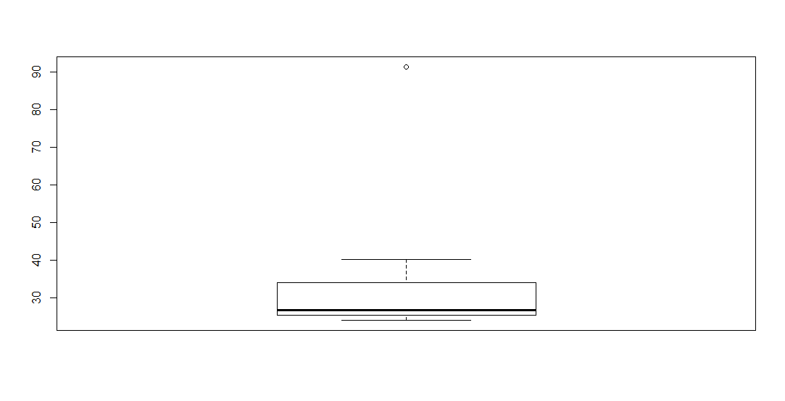

Mean = 33.37

Sd=16.9454

Variance=287.1466

Morgan Stanley = 91.36 is the outlier

2.



Answer the following three questions based on the box-plot above.

1. What is inter-quartile range of this dataset? (please approximate the numbers) In one line, explain what this value implies.

IQR = 12-5 = 7 approximately ,The Inter Quartile range gives us a measurement of how spread out the entirety of our data set is

1. What can we say about the skewness of this dataset?

Right skewed, positive skewed

1. If it was found that the data point with the value 25 is actually 2.5, how would the new box-plot be affected?

The mean value will be changed



Answer the following three questions based on the histogram above.

1. Where would the mode of this dataset lie?

Mode lies between 4 and 8

1. Comment on the skewness of the dataset.

Dataset is right skewed

1. Suppose that the above histogram and the box-plot in question 2 are plotted for the same dataset. Explain how these graphs complement each other in providing information about any dataset.

Median in boxplot and Mode in histogram as Histogram provides the frequency distribution so we can see how many times each data point is occurring however boxplot provides the quantile distribution i.e. 50% data lies between 5 and 12.

Boxplot provides length to identify outliers, no information from histogram. We can only guess looking at the gap that 25 may be an outlier.

1. AT&T was running commercials in 1990 aimed at luring back customers who had switched to one of the other long-distance phone service providers. One such commercial shows a businessman trying to reach Phoenix and mistakenly getting Fiji, where a half-naked native on a beach responds incomprehensibly in Polynesian. When asked about this advertisement, AT&T admitted that the portrayed incident did not actually take place but added that this was an enactment of something that “could happen.” Suppose that one in 200 long-distance telephone calls is misdirected. What is the probability that at least one in five attempted telephone calls reaches the wrong number? (Assume independence of attempts.)

One wrong number out of 200

Probability of wrong number: P(WN) = 1/200 = 0.005

Probability of not wrong number: 1 - P(WN) =1- 1/200 = 0.995

Probability of at least one out of five is a wrong number

= 1 – Probability that all five calls are not wrong numbers= 1 – (1 – P(WN))^5

= 1 – (1-0.005)^5

= 1 – 0.975

= 0.024

1. Returns on a certain business venture, to the nearest $1,000, are known to follow the following probability distribution

|  |  |
| --- | --- |
| x | P(x) |
| -2,000 | 0.1 |
| -1,000 | 0.1 |
| 0 | 0.2 |
| 1000 | 0.2 |
| 2000 | 0.3 |
| 3000 | 0.1 |

1. What is the most likely monetary outcome of the business venture?

Max. P = 0.3 for P(2000). So most likely outcome is 2000

1. Is the venture likely to be successful? Explain

since the probability of non negative returns is more than 0.5 which is 50%, the venture will be successful if these rates are maintained. 0.2+0.3+0.1=0.6

1. What is the long-term average earning of business ventures of this kind? Explain

p(x)*x = (-2000*0.1)+(-1000*0.1)+(0*0.2)+(1000*0.2)+(2000*0.3)+(3000*0.1)

= -200-100+0+200+600+300=800

1. What is the good measure of the risk involved in a venture of this kind? Compute this measure

P(loss) = P(x= -2000)+P(x=-1000)=0.2. So the risk associated with this venture is 20%.